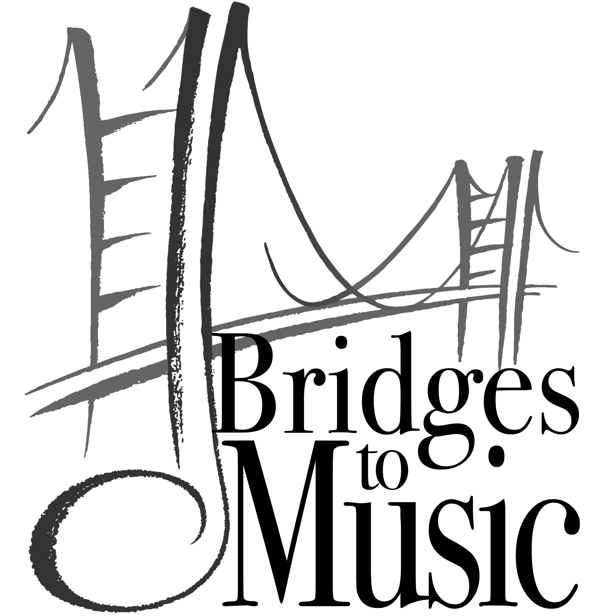
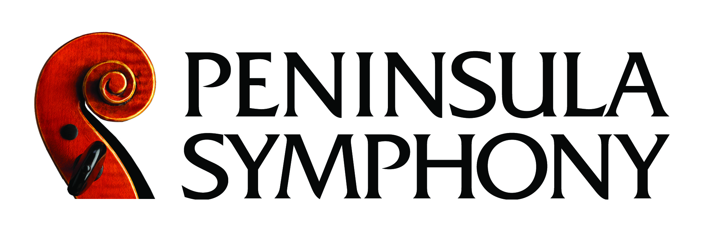

YOUNG MUSICIANS’ COMPETITION

WHO CAN PARTICIPATE?
- Student applicants must be participants in their school music program.
- Applicants must be high school sophomores, juniors, or seniors in San Francisco, San Mateo or Santa Clara County schools.
- All orchestral instruments accepted.

HOW DO I AUDITION?
- Applications must be received by mail or fax by Wednesday, March 20, 2019.
- Auditions are in the afternoon of Saturday, March 30, 2019 at College of San Mateo.
- A non-refundable $40 application fee (check payable to the Peninsula Symphony) is due with the application.
- Total audition time is 10 minutes per applicant. Cuts are suggested to conform to the time limit.

WHAT SHOULD I PLAY?
- One solo unaccompanied work (Bach unaccompanied, major étude, etc…)
- One movement of a concerto or major work that can be performed with a symphony orchestra. Concertos must be approved by PSO Music Director.
- Both works together must conform to the time limit of 10 minutes.
- IMPORTANT: Participants must provide their own accompanist and three (3) copies of their music for the judges.
- If you need an accompanist, we recommend Dmitriy Cogan who is available. Contact him directly at dmitriycogan@gmail.com or (650) 504-1619 to coordinate arrangements ($50 for competition, $60 per hour of rehearsal).

WHAT CAN I WIN?
- FIRST PRIZE - $500.00, and a solo appearance with the Peninsula Symphony on Saturday, June 22, 2019 at 6:00pm at Hillview Park in Los Altos.
- SECOND PRIZE - $200.00
- THIRD PRIZE - $100.00

Peninsula Symphony, 146 Main Street, Suite 102, Los Altos, CA 94022
Phone: (650) 941-5291 Fax: (650) 941-5292
www.peninsulasymphony.org

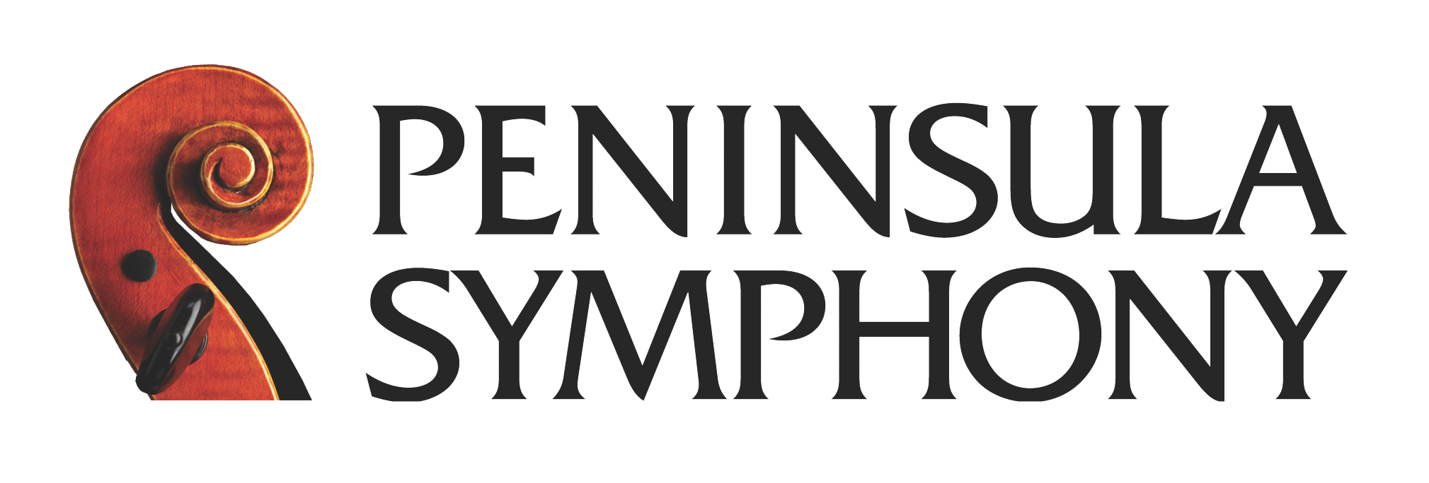
Young Musicians’ Competition

AUDITION APPLICATION

Mail to Peninsula Symphony, 146 Main Street, Suite 102, Los Altos, CA 94022

or email to info@peninsulasymphony.org by Wednesday March 20, 2019 with a $40 application fee.

PLEASE PRINT CLEARLY.

NAME _____________________________________________________________________________GRADE _________

HOME PHONE (_______) ___________________ EMAIL __________________________________________________

GUARDIAN NAME & EMAIL ________________________________________________________________________
ADDRESS _________________________________________________________________________________________

CITY __________________________________________________________________ ZIP ________________________

INSTRUMENT _______________YEARS PLAYED ______ SCHOOL ________________________________________

PRIVATE TEACHER’S NAME ___________________________________________ YEARS STUDIED ____________

Required information:

SCHOOL MUSIC DIRECTOR __________________________ SIGNATURE ___________________________________

LIST REPERTOIRE TO BE PLAYED AT THE AUDITION:

(1) SOLO UNACCOMPANIED WORK: ______________________________________ COMPOSER: ______________

(2) ONE MOVEMENT OF A CONCERTO OR MAJOR WORK THAT CAN BE PERFORMED WITH ORCHESTRA:

SELECTION: ____________________________________________ COMPOSER: _______________________________

AUDITION ACCOMPANIST NAME: ___________________________________________________________________

REMINDERS:
- Auditions will be held in the afternoon of Saturday March 30, 2019 at College of San Mateo. Audition times will be sent to each participant.
- A non-refundable application fee of $40 (check payable to the Peninsula Symphony) must accompany this application. If there is a condition of financial difficulty, please contact the competition office at 650-941-5291.
- Audition time is limited to 10 minutes. Applicants should make cuts to conform to time requirement.
- IMPORTANT: Participants must provide their own accompanist and three (3) copies of their music for the judges.
- Applicants must be available to perform on the Peninsula Symphony Summer Concert on June 22nd, 2019 (4:30pm sound check, 6:00pm concert) in Los Altos (rehearsal on June 18th at 7:30pm in Hillsborough).
- 1st Prize: $500.00 and a solo performance with the Peninsula Symphony June 22nd, 2019.
2nd Prize: $200.00
3rd Prize: $100.00

